Cron job

Vi cronjob.yml

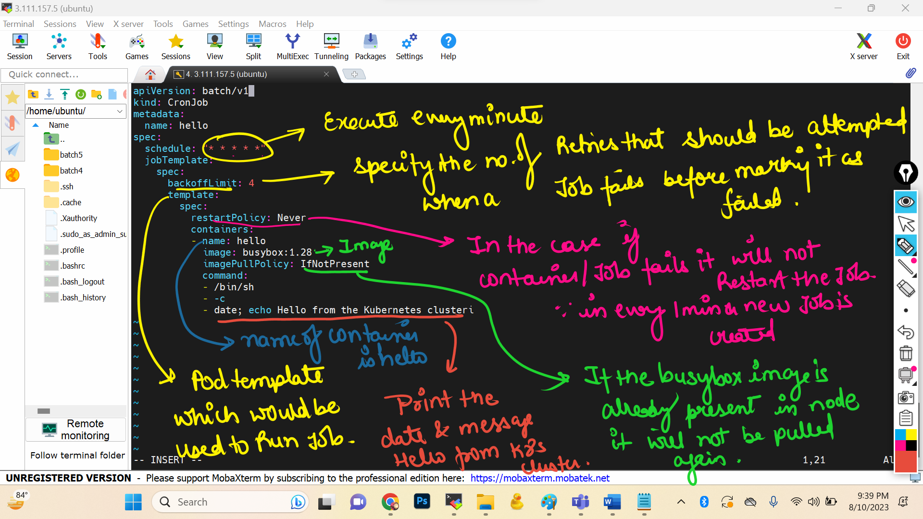

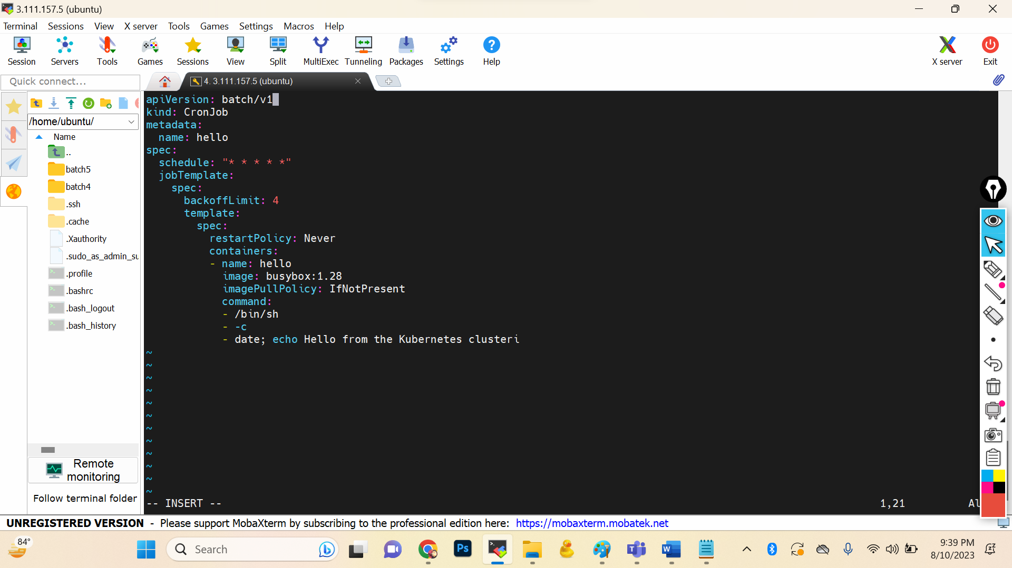

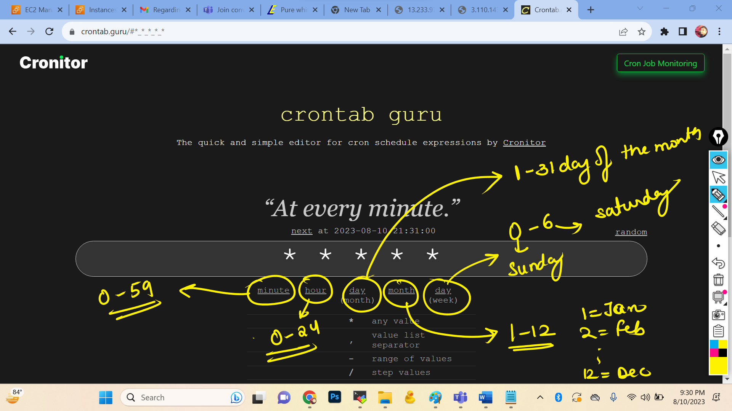

apiVersion: batch/v1

kind: CronJob

metadata:

name: hello

spec:

schedule: "\* \* \* \* \*"

jobTemplate:

spec:

backoffLimit: 4

template:

spec:

restartPolicy: Never

containers:

- name: hello

image: busybox:1.28

imagePullPolicy: IfNotPresent

command:

- /bin/sh

- -c

- date; echo Hello from the Kubernetes clusteri



